Utah School Nurses
Save Lives...Save Money

School Nurses Save Lives
Last year in Utah, 27 student lives were saved through administration of epinephrine at school.

School Nurses Screen for Health-Related Conditions that Interfere with Learning
Last year 283,748 students received vision-screening services. Of those, 17,374 were referred for further care by an eye care professional. Over 4,300 students received ﬁnancial assistance for vision exams and glasses by using coupons provided by a school nurse.

School Nurses Return More Students to Class
Unlicensed lay staﬀ sends more students home because they do not have the specialized training and assessment skills of a registered nurse. During the 2017-2018 school year school nurses returned students to the classroom 89% of the time as compared to 70% of students returned to class by unlicensed staff members. School nurses keep students in school, ready to learn.

School Nurses Increase Teaching Eﬃciency
With a school nurse on site, teachers and other students in class are less distracted by fearful circumstances. One school nurse saves each school in lost productivity costs about 57 minutes for each principal, 46 minutes for each clerical staﬀ, and 20 minutes for each teacher every day.

School Nurses Allow Districts to Meet Legal Requirements
By providing medical care to students at school including: training, delegating, and utilizing proper documentation procedures, school nurses help prevent legal liability for schools by promoting correct care delivery.

“School Nurses enhance each child’s educational potential by promoting physical and emotional wellness, increasing school attendance, and decreasing non-academic barriers to learning.”
Dr. William Cosgrove

U.S. School Nurse Funding (Public Schools)⁵

www.utahschoolnurses.org

What would it take?

By investing about $140 per student per year, Utah could
place a school nurse in every school with
costs totaling $91,000,000.
Utah's legislature currently spends $1,002,000.00 on school nurses, which equates to
$1.54 per student, per year.
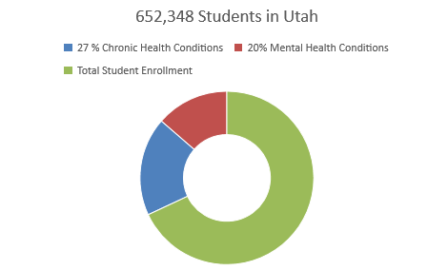

- Approximately 27% of students have a chronic health condition 1 (i.e., diabetes, asthma, allergies, seizure, heart conditions, cancers), and up to 20% of students have mental health conditions 2, 3 (i.e., ADHD, depression, anxiety, eating disorders, self-injury).

- School nurses spend a signiﬁcant amount of their time (up to 40%) working with students with mental health conditions 4.

- School nurses view students in a "holistic" manner considering the physiologic and emotional states that can alter a child’s educational readiness. School nurses are trained to calmly handle both medical and emotional crises in students. This frees the teacher to focus on teaching.

- School nurses have the specialized training and assessment skills necessary to provide the competent caring hands and conﬁdent, calming voice, which brings immediate comfort to a frightened child who is ill or injured.

1 Van Cleave, J., Gortmaker, S.L., & Perrin, J.M. (2010) Dynamics of obesity and chronic health condi6ons among children and youth. Journal of American Medical Association, 303(7), 623-630.
2 World Health Organizaton. (2017). Global accelerated action for health of adolescents (AA-HA!): Guidance to support country implementation. Geneve: World Health Organization.
3 Maryland Department of Health and Mental Hygiene, Missouri Department of Mental Health, and National Council for Community Behavioral Healthcare (2012). Youth Mental Health First Aid USA for Adults Assisting Young People.
4 Ravenna, J., & Cleaver, K. (2016). School Nurses' experience of managing young people with mental health problems: A
scoping review. The Journal of School Nursing 2016, 32(1), 58-70.
⁵ Willgerodt, M.A., Brock, D. M., & Maughan, E.M. (2018). Public School Nursing Practice in the United States. Journal of School Nursing, 34(3), 232-244.

